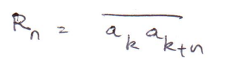

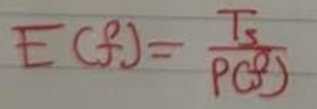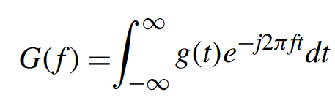

|  |  |  |
| --- | --- | --- |
| Polar |  | BW = 2Rb --- 4x Nyquist rate (for half width)  BW = Rb (for full pulse width)  Most efficient, has DC comp  Can use Manchester to remove DC comp |
| ON-OFF |  | Requires twice polar pwr |
| Bipolar |  | DC Null, BW = Rb (2x Nyq), Has single bit error det  Requires twice pwr of polar |

ON-OFF